1 run

training 1 epoch...

65.66963315010071 seconds used......

1 training finished! average train loss: 0.6532153014770963

evaluating...

Confusion matrix, without normalization

[[ 98 17 19]

[ 404 1478 55]

[ 25 9 373]]

Normalized confusion matrix

[[0.73134328 0.12686567 0.14179104]

[0.20856995 0.76303562 0.02839442]

[0.06142506 0.02211302 0.91646192]]

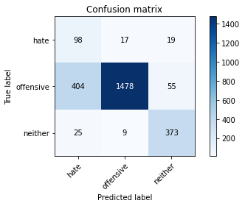

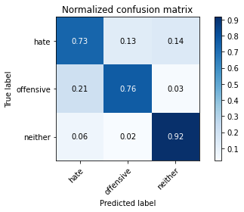

precision recall f1-score support

hate 0.19 0.73 0.30 134

offensive 0.98 0.76 0.86 1937

neither 0.83 0.92 0.87 407

accuracy 0.79 2478

macro avg 0.67 0.80 0.68 2478

weighted avg 0.92 0.79 0.83 2478

average eval_loss: 0.49638569006516087, accuracy: 0.7865213882163035

training 2 epoch...

65.72653341293335 seconds used......

2 training finished! average train loss: 0.3830970287407664

evaluating...

Confusion matrix, without normalization

[[ 93 21 20]

[ 339 1487 111]

[ 14 5 388]]

Normalized confusion matrix

[[0.69402985 0.15671642 0.14925373]

[0.17501291 0.76768198 0.05730511]

[0.03439803 0.01228501 0.95331695]]

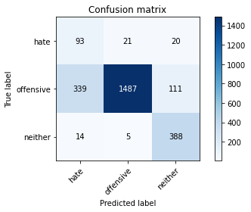

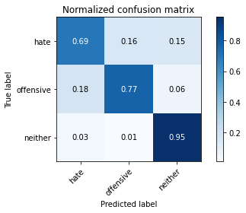

precision recall f1-score support

hate 0.21 0.69 0.32 134

offensive 0.98 0.77 0.86 1937

neither 0.75 0.95 0.84 407

accuracy 0.79 2478

macro avg 0.65 0.81 0.67 2478

weighted avg 0.90 0.79 0.83 2478

average eval_loss: 0.5366633076581263, accuracy: 0.7941888619854721

training 3 epoch...

65.47798228263855 seconds used......

3 training finished! average train loss: 0.2652854674961418

evaluating...

Confusion matrix, without normalization

[[ 97 27 10]

[ 341 1552 44]

[ 33 21 353]]

Normalized confusion matrix

[[0.7238806 0.20149254 0.07462687]

[0.17604543 0.80123903 0.02271554]

[0.08108108 0.05159705 0.86732187]]

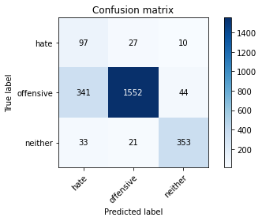

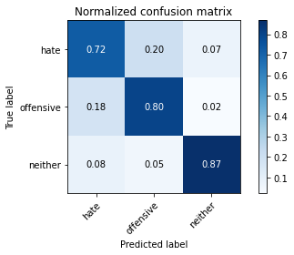

precision recall f1-score support

hate 0.21 0.72 0.32 134

offensive 0.97 0.80 0.88 1937

neither 0.87 0.87 0.87 407

accuracy 0.81 2478

macro avg 0.68 0.80 0.69 2478

weighted avg 0.91 0.81 0.85 2478

average eval_loss: 0.4846776432447856, accuracy: 0.807909604519774

training 4 epoch...

65.47658729553223 seconds used......

4 training finished! average train loss: 0.145517867481844

evaluating...

Confusion matrix, without normalization

[[ 89 31 14]

[ 272 1611 54]

[ 30 12 365]]

Normalized confusion matrix

[[0.6641791 0.23134328 0.10447761]

[0.14042334 0.8316985 0.02787816]

[0.07371007 0.02948403 0.8968059 ]]

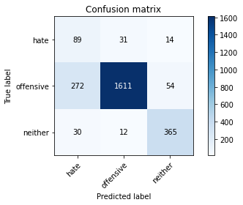

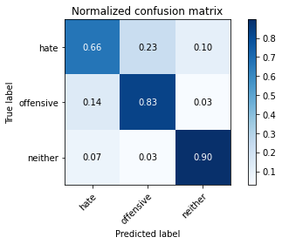

precision recall f1-score support

hate 0.23 0.66 0.34 134

offensive 0.97 0.83 0.90 1937

neither 0.84 0.90 0.87 407

accuracy 0.83 2478

macro avg 0.68 0.80 0.70 2478

weighted avg 0.91 0.83 0.86 2478

average eval_loss: 0.5276914093823682, accuracy: 0.8333333333333334

training 5 epoch...

65.54813718795776 seconds used......

5 training finished! average train loss: 0.07510574699898082

evaluating...

Confusion matrix, without normalization

[[ 83 34 17]

[ 244 1630 63]

[ 15 19 373]]

Normalized confusion matrix

[[0.61940299 0.25373134 0.12686567]

[0.12596799 0.84150749 0.03252452]

[0.03685504 0.04668305 0.91646192]]

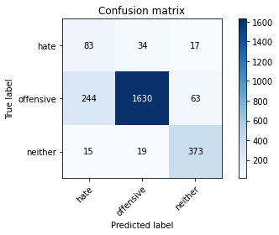

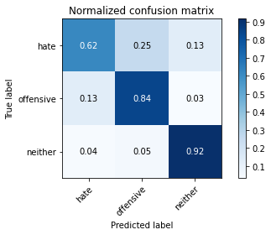

precision recall f1-score support

hate 0.24 0.62 0.35 134

offensive 0.97 0.84 0.90 1937

neither 0.82 0.92 0.87 407

accuracy 0.84 2478

macro avg 0.68 0.79 0.71 2478

weighted avg 0.91 0.84 0.87 2478

average eval_loss: 0.5828012739713755, accuracy: 0.8418079096045198

model of 1 epoch

Confusion matrix, without normalization

[[ 93 24 7]

[ 406 1475 61]

[ 25 7 381]]

Normalized confusion matrix

[[0.75 0.19354839 0.05645161]

[0.20906282 0.75952626 0.03141092]

[0.06053269 0.01694915 0.92251816]]

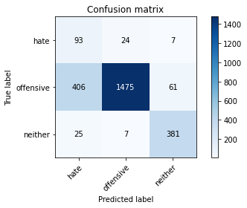

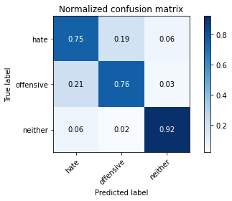

precision recall f1-score support

hate 0.18 0.75 0.29 124

offensive 0.98 0.76 0.86 1942

neither 0.85 0.92 0.88 413

accuracy 0.79 2479

macro avg 0.67 0.81 0.68 2479

weighted avg 0.92 0.79 0.83 2479

average eval_loss: 0.5190498082628173, accuracy: 0.7862041145623235

2 run

training 1 epoch...

65.3932638168335 seconds used......

1 training finished! average train loss: 0.6472269271246411

evaluating...

Confusion matrix, without normalization

[[ 100 21 13]

[ 402 1491 44]

[ 37 9 361]]

Normalized confusion matrix

[[0.74626866 0.15671642 0.09701493]

[0.20753743 0.76974703 0.02271554]

[0.09090909 0.02211302 0.88697789]]

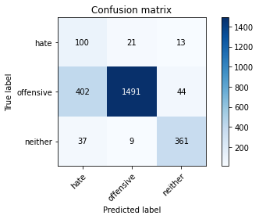

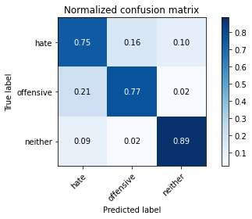

precision recall f1-score support

hate 0.19 0.75 0.30 134

offensive 0.98 0.77 0.86 1937

neither 0.86 0.89 0.88 407

accuracy 0.79 2478

macro avg 0.68 0.80 0.68 2478

weighted avg 0.92 0.79 0.83 2478

average eval_loss: 0.4757975643921283, accuracy: 0.7877320419693301

training 2 epoch...

65.37678647041321 seconds used......

2 training finished! average train loss: 0.3748370737938041

evaluating...

Confusion matrix, without normalization

[[ 106 11 17]

[ 469 1427 41]

[ 30 12 365]]

Normalized confusion matrix

[[0.79104478 0.08208955 0.12686567]

[0.242127 0.73670625 0.02116675]

[0.07371007 0.02948403 0.8968059 ]]

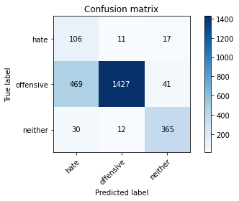

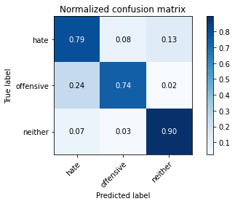

precision recall f1-score support

hate 0.18 0.79 0.29 134

offensive 0.98 0.74 0.84 1937

neither 0.86 0.90 0.88 407

accuracy 0.77 2478

macro avg 0.67 0.81 0.67 2478

weighted avg 0.92 0.77 0.82 2478

average eval_loss: 0.5636993608167095, accuracy: 0.7659402744148507

training 3 epoch...

65.40235686302185 seconds used......

3 training finished! average train loss: 0.2589218113994734

evaluating...

Confusion matrix, without normalization

[[ 103 19 12]

[ 385 1506 46]

[ 41 14 352]]

Normalized confusion matrix

[[0.76865672 0.14179104 0.08955224]

[0.19876097 0.77749097 0.02374806]

[0.1007371 0.03439803 0.86486486]]

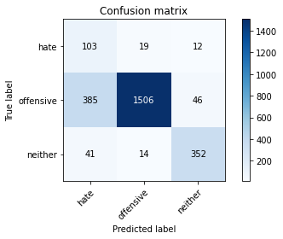

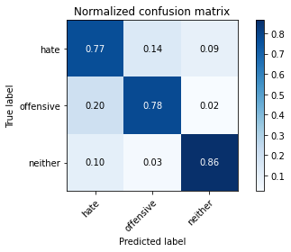

precision recall f1-score support

hate 0.19 0.77 0.31 134

offensive 0.98 0.78 0.87 1937

neither 0.86 0.86 0.86 407

accuracy 0.79 2478

macro avg 0.68 0.80 0.68 2478

weighted avg 0.92 0.79 0.84 2478

average eval_loss: 0.5484562625567759, accuracy: 0.79136400322841

training 4 epoch...

65.40855526924133 seconds used......

4 training finished! average train loss: 0.15207050427984956

evaluating...

Confusion matrix, without normalization

[[ 99 19 16]

[ 323 1565 49]

[ 21 23 363]]

Normalized confusion matrix

[[0.73880597 0.14179104 0.11940299]

[0.16675271 0.80795044 0.02529685]

[0.05159705 0.05651106 0.89189189]]

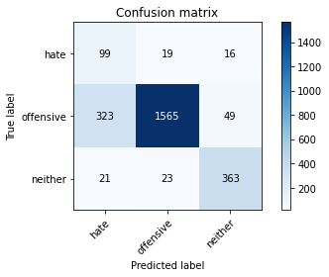

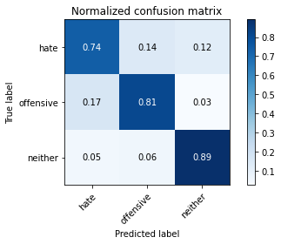

precision recall f1-score support

hate 0.22 0.74 0.34 134

offensive 0.97 0.81 0.88 1937

neither 0.85 0.89 0.87 407

accuracy 0.82 2478

macro avg 0.68 0.81 0.70 2478

weighted avg 0.91 0.82 0.85 2478

average eval_loss: 0.5380118955527583, accuracy: 0.817998385794996

training 5 epoch...

65.45771980285645 seconds used......

5 training finished! average train loss: 0.06997495576136069

evaluating...

Confusion matrix, without normalization

[[ 96 23 15]

[ 289 1618 30]

[ 20 34 353]]

Normalized confusion matrix

[[0.71641791 0.17164179 0.1119403 ]

[0.14919979 0.83531234 0.01548787]

[0.04914005 0.08353808 0.86732187]]

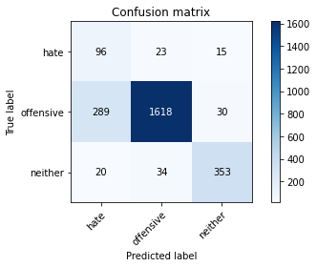

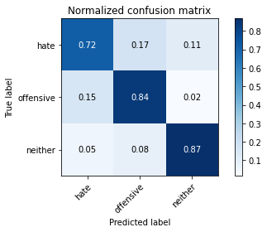

precision recall f1-score support

hate 0.24 0.72 0.36 134

offensive 0.97 0.84 0.90 1937

neither 0.89 0.87 0.88 407

accuracy 0.83 2478

macro avg 0.70 0.81 0.71 2478

weighted avg 0.91 0.83 0.86 2478

average eval_loss: 0.6063357797871914, accuracy: 0.8341404358353511

Confusion matrix, without normalization

[[ 99 19 6]

[ 476 1419 47]

[ 30 10 373]]

Normalized confusion matrix

[[0.7983871 0.15322581 0.0483871 ]

[0.24510814 0.73069001 0.02420185]

[0.07263923 0.02421308 0.9031477 ]]

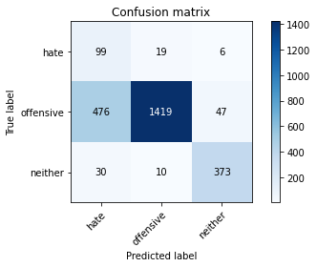

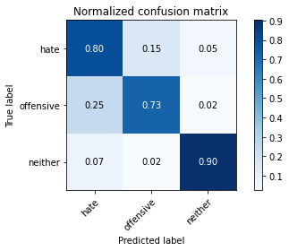

precision recall f1-score support

hate 0.16 0.80 0.27 124

offensive 0.98 0.73 0.84 1942

neither 0.88 0.90 0.89 413

accuracy 0.76 2479

macro avg 0.67 0.81 0.67 2479

weighted avg 0.92 0.76 0.82 2479

average eval_loss: 0.5836734446066041, accuracy: 0.7628075837031061

[25]:

0.7628075837031061

3 run

training 1 epoch...

65.40363144874573 seconds used......

1 training finished! average train loss: 0.7129631769758734

evaluating...

Confusion matrix, without normalization

[[ 105 18 11]

[ 376 1511 50]

[ 52 9 346]]

Normalized confusion matrix

[[0.78358209 0.13432836 0.08208955]

[0.19411461 0.78007228 0.02581311]

[0.12776413 0.02211302 0.85012285]]

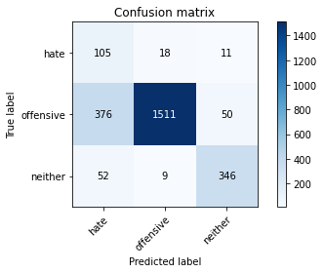

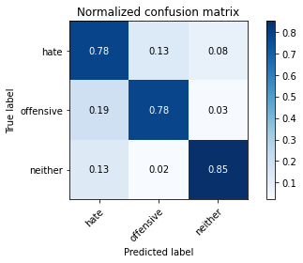

precision recall f1-score support

hate 0.20 0.78 0.31 134

offensive 0.98 0.78 0.87 1937

neither 0.85 0.85 0.85 407

accuracy 0.79 2478

macro avg 0.68 0.80 0.68 2478

weighted avg 0.92 0.79 0.84 2478

average eval_loss: 0.5937829368537472, accuracy: 0.7917675544794189

training 2 epoch...

65.44582629203796 seconds used......

2 training finished! average train loss: 0.38840239791368897

evaluating...

Confusion matrix, without normalization

[[ 91 21 22]

[ 347 1491 99]

[ 14 6 387]]

Normalized confusion matrix

[[0.67910448 0.15671642 0.1641791 ]

[0.179143 0.76974703 0.05110996]

[0.03439803 0.01474201 0.95085995]]

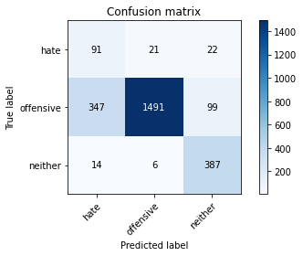

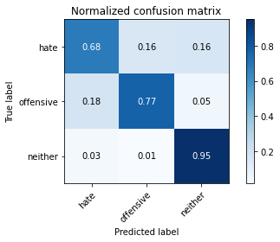

precision recall f1-score support

hate 0.20 0.68 0.31 134

offensive 0.98 0.77 0.86 1937

neither 0.76 0.95 0.85 407

accuracy 0.79 2478

macro avg 0.65 0.80 0.67 2478

weighted avg 0.90 0.79 0.83 2478

average eval_loss: 0.532620741475013, accuracy: 0.794592413236481

training 3 epoch...

65.42163157463074 seconds used......

3 training finished! average train loss: 0.2617161154577678

evaluating...

Confusion matrix, without normalization

[[ 86 26 22]

[ 231 1575 131]

[ 13 5 389]]

Normalized confusion matrix

[[0.64179104 0.19402985 0.1641791 ]

[0.11925658 0.81311306 0.06763036]

[0.03194103 0.01228501 0.95577396]]

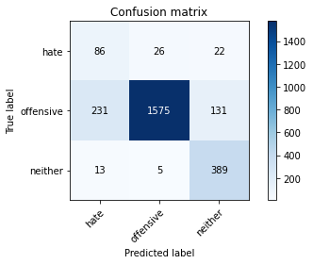

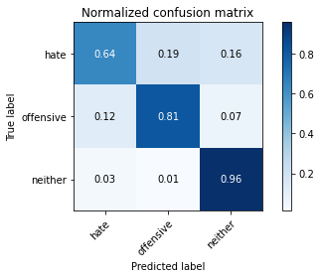

precision recall f1-score support

hate 0.26 0.64 0.37 134

offensive 0.98 0.81 0.89 1937

neither 0.72 0.96 0.82 407

accuracy 0.83 2478

macro avg 0.65 0.80 0.69 2478

weighted avg 0.90 0.83 0.85 2478

average eval_loss: 0.49249471796135746, accuracy: 0.8272800645682001

training 4 epoch...

65.46616649627686 seconds used......

4 training finished! average train loss: 0.15055012380153956

evaluating...

Confusion matrix, without normalization

[[ 105 15 14]

[ 430 1465 42]

[ 32 23 352]]

Normalized confusion matrix

[[0.78358209 0.1119403 0.10447761]

[0.22199277 0.75632421 0.02168301]

[0.07862408 0.05651106 0.86486486]]

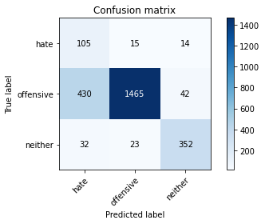

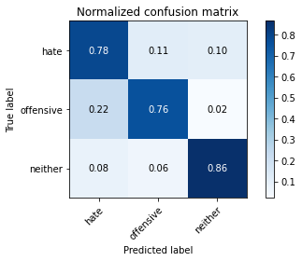

precision recall f1-score support

hate 0.19 0.78 0.30 134

offensive 0.97 0.76 0.85 1937

neither 0.86 0.86 0.86 407

accuracy 0.78 2478

macro avg 0.67 0.80 0.67 2478

weighted avg 0.91 0.78 0.82 2478

average eval_loss: 0.6338602675785941, accuracy: 0.7756255044390638

training 5 epoch...

65.4487693309784 seconds used......

5 training finished! average train loss: 0.08292646770926447

evaluating...

Confusion matrix, without normalization

[[ 99 24 11]

[ 327 1568 42]

[ 32 29 346]]

Normalized confusion matrix

[[0.73880597 0.17910448 0.08208955]

[0.16881776 0.80949923 0.02168301]

[0.07862408 0.07125307 0.85012285]]

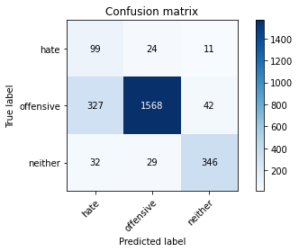

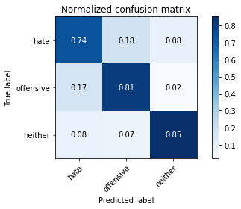

precision recall f1-score support

hate 0.22 0.74 0.33 134

offensive 0.97 0.81 0.88 1937

neither 0.87 0.85 0.86 407

accuracy 0.81 2478

macro avg 0.68 0.80 0.69 2478

weighted avg 0.91 0.81 0.85 2478

average eval_loss: 0.6560090838841373, accuracy: 0.8123486682808717

Confusion matrix, without normalization

[[ 98 21 5]

[ 391 1488 63]

[ 47 5 361]]

Normalized confusion matrix

[[0.79032258 0.16935484 0.04032258]

[0.20133883 0.76622039 0.03244078]

[0.11380145 0.01210654 0.87409201]]

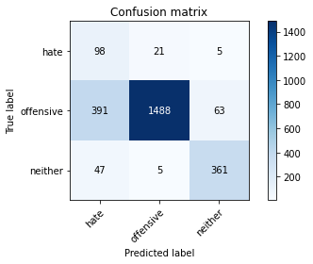

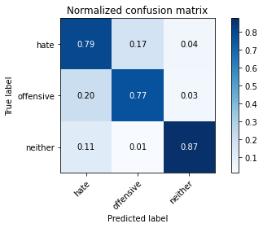

precision recall f1-score support

hate 0.18 0.79 0.30 124

offensive 0.98 0.77 0.86 1942

neither 0.84 0.87 0.86 413

accuracy 0.79 2479

macro avg 0.67 0.81 0.67 2479

weighted avg 0.92 0.79 0.83 2479

average eval_loss: 0.6180714147706186, accuracy: 0.7853973376361436

[27]:

0.7853973376361436